14,524.48
TOTAL VOLUNTEER HOURS THROUGH MARCH 8TH

(PHOTO TAKEN BEFORE COVID-19)

$25,000 AND OVER
2019-2020 READ WITH ME CONTRIBUTIONS
The Auen Foundation Jeannie & Jim Morris
Bill & Ruth Scott/Omaha Community Foundation

$15,000 to $24,999
The H. N. & Francis C. Berger Foundation
Evans Family Foundation

$10,000 to $14,999
Barbara & Tad Danz
Dave & Cheryl Duffield Foundation Patrick (Edie) McCarthy Foundation Sacred Heart Church
Snow Family Foundation (Ron & Aviva)

$5,000 to $9,999
BIGHORN Golf Club Charities Coachella Valley Unified School
District*
Dr. Seuss Foundation Friendship Church Molly Harris
Roberta & Clay Klein
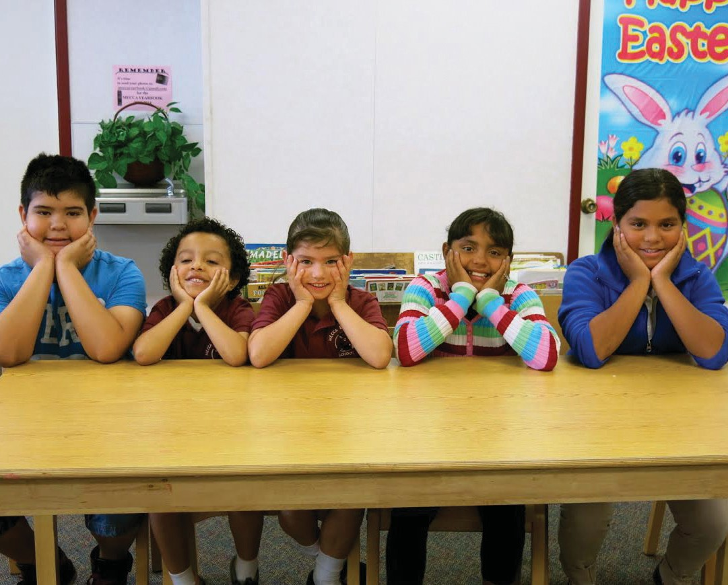The McMurtry Family Foundation Riley Family Trust (Karen Goldrick) Rite Aid Foundation-KidCents Rodman Foundation (Amanda Rios
PARTICIPATING SCHOOLS, VOLUNTEER COORDINATORS & SPONSORS
2019-2020
Heintz)
Gary Severtson

$1,000 to $4,999
Judy & John Austin Lynn & Robert Baersch
Jaqueline & Martin Casey

City of Cathedral City City of Coachella
City of Indian Wells City of Indio
Community Presbyterian Church Judith & David Collins
Carroll Cook
Mary & Dr. Howard Destefano Fabricure DBA Fashion Cleaners Willliam Hall
Jean & Steven Hamerslag Ralph Hemingway
Gerald & Linda Hermanson Steve Hoffman
Hope Lutheran Church (Derek Fossey)
Peggy Jacobs
Klintworth Foundation (Kimberly & Skip)
John Kulow, PGA GM Monterey CC of PD
Marcia & Steve Larson Charitable Fund
Fran Panico
Grace Helen Spearman Foundation Robert Summers Langerstom/Gillespie Family
Lynda & James Morely Magdalen & J. Patrick Mulcaly Northwest Storage Foundation Parasol Tahoe Community
Foundation/Claudia Anderson Wanda & Garry Walsh
The Champions Volunteer

Foundation
The Community Foundation (Youth Grantmakers)
The Community Foundation (Bud & Myrna La Rue)
The Woman’s Club of Indio

$500 to $999
Stephen Benzek
Margaret & Thomas Connelly Michael & Jacquelyn Flood Cheryl & William Howard Roberta Jones
Theodore H. Kruttschnitt James Logson
Victoria & Brian Lord Mary & Dr. Howard Maron Michelle & Kevin McArthur Pam & Peter Mcllroy
Karin McGuire Theresa McPherson Mary (Lois) Monahan JoAnne & Nick Moore Rita & Richard Murase Linda & Robert Pike
Pledgeling Foundation/Dan Giovannitti
Paul & Gayle Romain Frank & Ann Sidles Gerald Starek
Marsha & Glen Stocking Barbara Storwick
Sun City Literacy Guild & Writers Club
Gerrit & Nancy Vaessen

$100 to $499
Barbara Adner
Karen & Edward Anschell Robert Barnett
S. J. Basista Reena Blumenfeld
Rodger Christensen Sherri DeBoer Harriette Dorkin Selby Dunham
East Valley Republican Womens Federation
Susan & Jim Eichberg Shelia Freeman Laura Fritz
Ernest & Judith Giovannitti Michael Giovannitti Pamela Green
Craig Grantham
Lana & R. Steven Hardy Marcy & Harry Harczak Ralph Hemingway Justine & John Higgins Vickie & Butch Holmes
Caroline & George Hubman
W. P. Johnson
Claiborne S. Jones TTEE Gerri Kahnweller Kathleen & Robert Kane
Margo Handlesman & Barry Kaufman
Arlene Kraines Mary & Rick Kratz
John & Sandra Leland Foundation

Deborah Lewis Richard Leza Donna MacMillian
Michael & Barbara McCarthy
R. Donald & Therese McNeil Barb & Tom Melby
Marie & Tim Mitchell Melanie & Manny Mitchell Carol Morton
JULY 1, 2019 – JUNE 30, 2020
Carol Pircon Guido Portante
VOLUNTEER PROGRAMS
Pamela Musselman Barbara Noujaim Dorothy & John Ownes Judith Pankoff
Janet & George Parsons Trisha Peters
Witta Priester Richard Rolla
Seecon Mangement LLC Seecon XIX, TIC Seecon XV11, TIC Maureen Stenger
Glen Stocking
Mary & John Sullivan Frank Thomsen Trilogy Book Club Raymond J. Triplett Victoria Vasilakos Sara & Nicholas Walz
Pamela & Steven Wexler

* Denotes in-kind donations

CATHEDRAL CITY ELEMENTARY SCHOOL
Cathedral City, CA Lynn Baersch baersch@aol.com

JACKSON ELEMENTARY SCHOOL

Indio, CA
Judy Hovjacky readwithmejudy@gmail.com Sponsored by Our Lady of Soledad

JOHN KELLEY ELEMENTARY

Thermal, CA
Bruce Titcomb bltitcomb@gmail.com Rebecca Ruffing Joslyn Program Director
Sponsored by Joslyn Senior Center

LAS PALMITAS ELEMENTARY

OASIS ELEMENTARY

Thermal, CA
Kathy Coplen

kcoplen@dc.rr.com
Sponsored by St. Margaret’s Episcopal & Palm Desert Presbyterian Church

PALM VIEW ELEMENTARY

Coachella, CA
Penny Wrobel readwithmepenny@gmail.com Wendy Falkowski wendyf@telus.net
Judy Haydock readwithmejhaydock@gmail.com Sponsored by Friendship Church

PETER PENDLETON ELEMENTARY

Coachella, CA
Fran Panico

VALLEY VIEW ELEMENTARY

Coachella, CA
Frank Leinen valleyviewreadwithme@gmail.com Pat Pearce papearce@earthlink.net
Sponsored by Southwest Church

VAN BUREN ELEMENTARY

Indio, CA
Carol Morton carol.morton@pacificsir.com Sponsored by-Sacred Heart Church &
Xavier Prep School

VALLE DEL SOL ELEMENTARY
Coachella, CA Margaret Wallace marrwall@aol.com
Sponsored by The Hideaway CC
Join Us
Help Break the Cycle of Poverty in Our Area

Volunteer
Work with Disadvantaged Children to Develop Their Maximum Potential
WWW.READWITHMEVOLUNTEERS.COM

FOR INFORMATION:
readwithmesd@gmail.com (email) or (760) 567-1830

DONATE:

Read with Me Volunteer Programs is a 501(c)(3) organization.
Fed Tax EIN #47-1406641. All contributions are fully tax deductible.

MISSION STATEMENT
To assist local children from a low income, limited English
speaking environment develop to their fullest potential by learning to read, comprehend and speak English, while understanding that people care about them as individuals.

Thermal, CA
Dan & Sandy Giovannitti daniel.giovannitti@gmail.com Sponsored by St. Francis Church

MECCA ELEMENTARY

Mecca, CA
Roberta Klein robertaeklein@gmail.com Sponsored by Sacred Heart Church

MOUNTAIN VISTA ELEMENTARY

Indio, CA
Alena Callimanis readwithmealena@gmail.com Sponsored by Our Lady of Soledad
franpanico@gmail.com Linda McCauley stubaby123@aol.com
Sponsored by Sacred Heart Church

RICHARD OLIPHANT ELEMENTARY

Indio, CA
Alena Callimanis readwithmealena@gmail.com Sponsored by Southwest Church

SAUL MARTINEZ ELEMENTARY

Mecca, CA
Horst Engel readwithmehorst@gmail.com Sponsored by Hope Lutheran Church

INCLINE VILLAGE ELEMENTARY

Incline Village, NV

VOLUNTEER PROGRAMS
Steve Wiggs swiggs@washoeschools.net Sylvia Purdy sylpurdy@gmail.com
Sponsored by Village Church, St. Patrick Episcopal & St Francis of Assisi

MARIPOSA ACADEMY

Reno, NV
Sue Foltz

suefoltz@yahoo.com
St. Francis of Assisi & Montreaux Country Club
$100

Buys 20 books for
Become a Contributor...
Together we can make a difference.
children to take home and share with their family

$300

Funds the training
of one volunteer to tutor remotely
$500

Buys equipment for
volunteers to tutor children remotely

$1,000

Funds one-on-one
remote volunteer tutoring for three students for a year

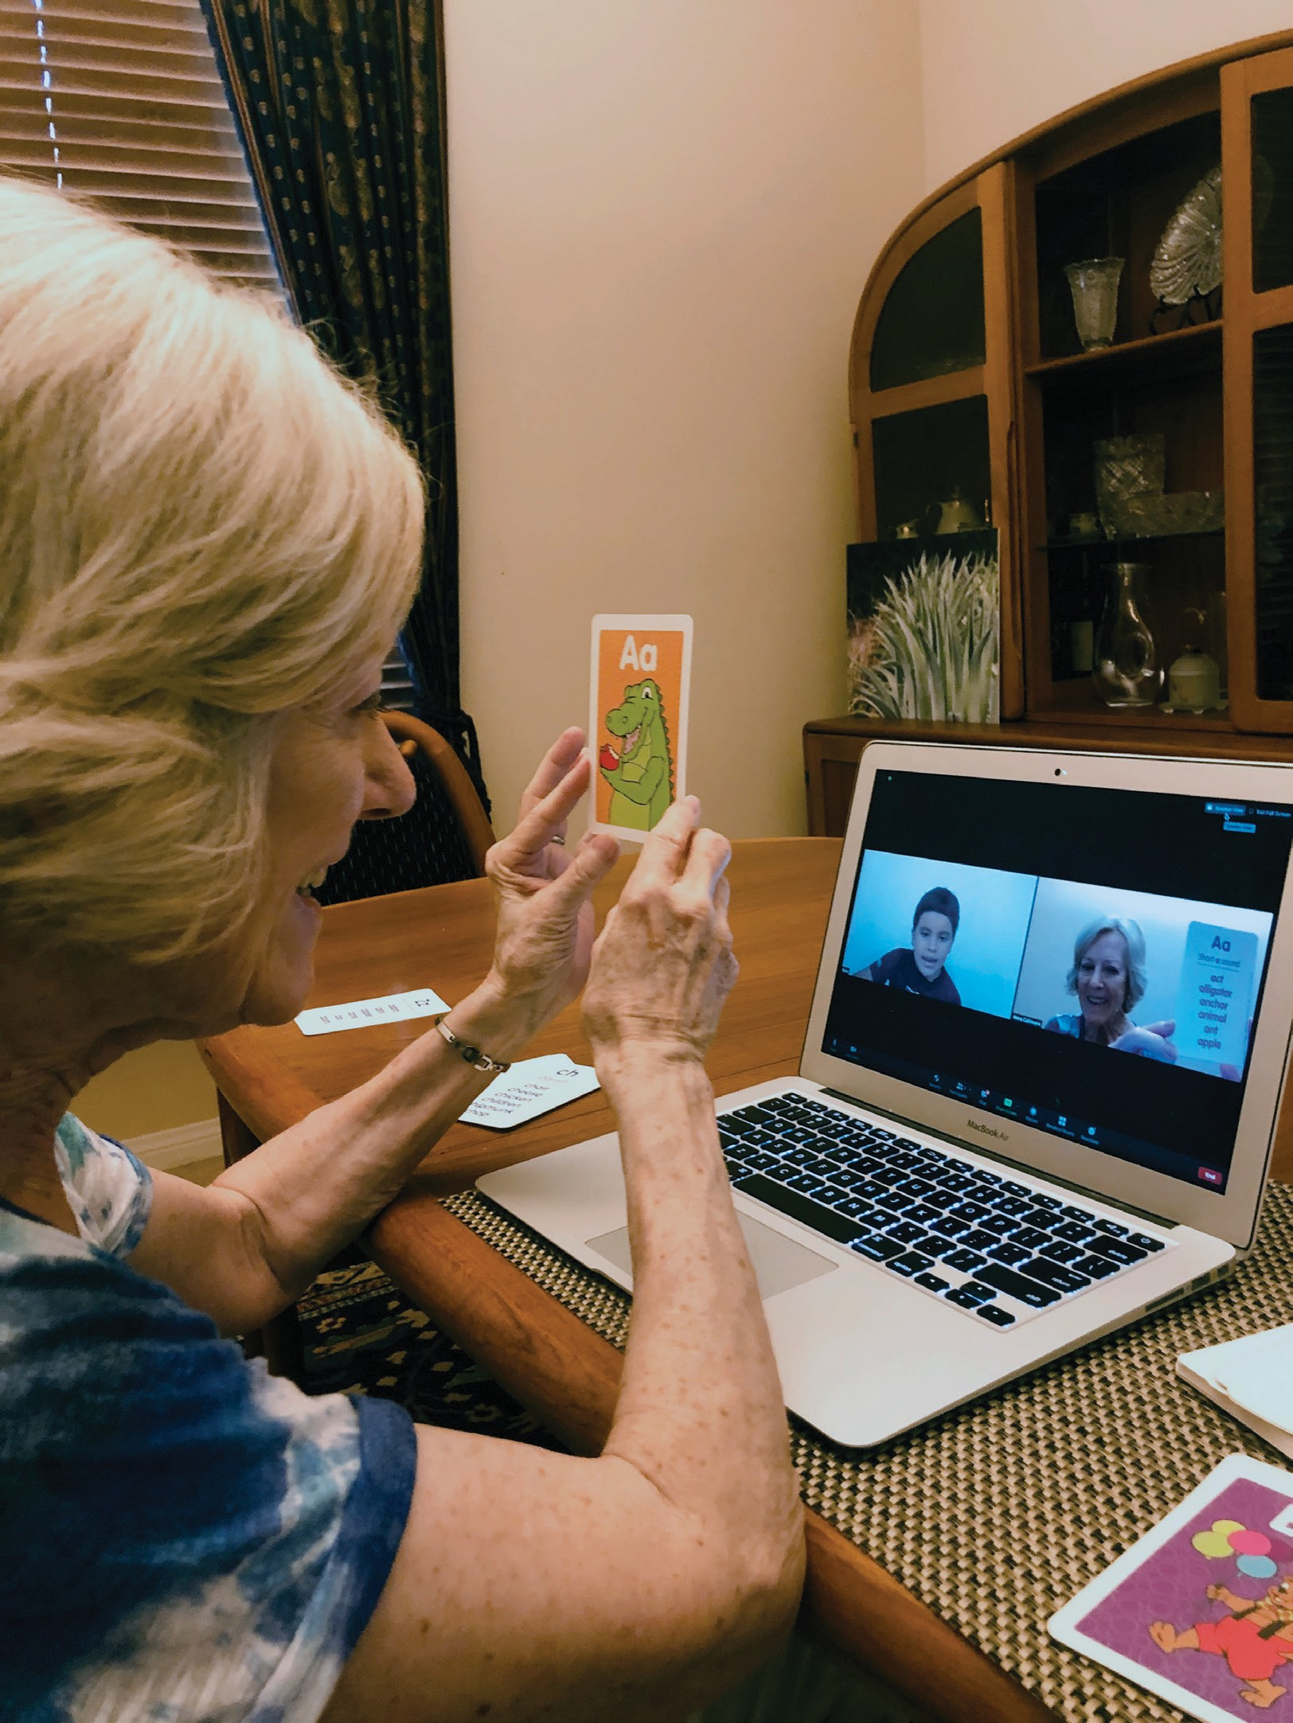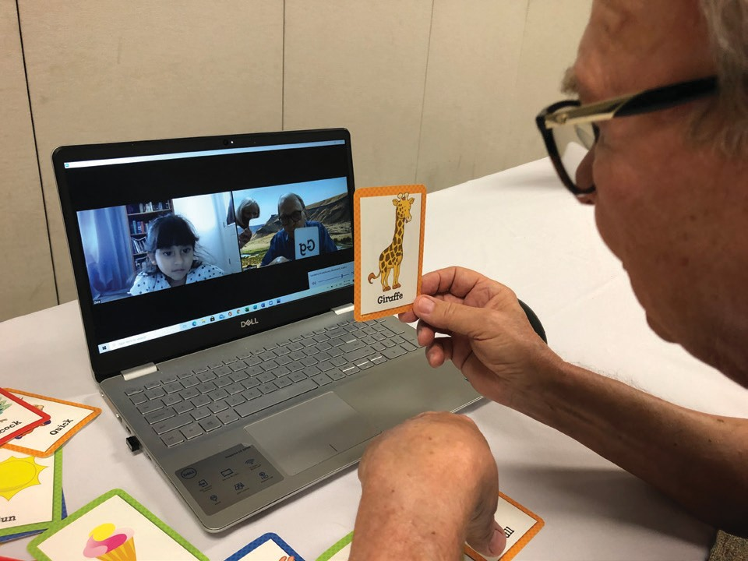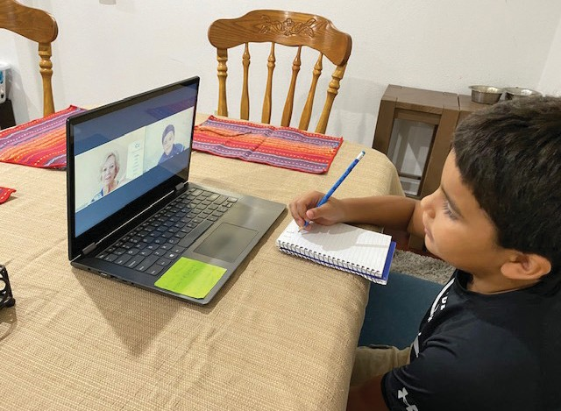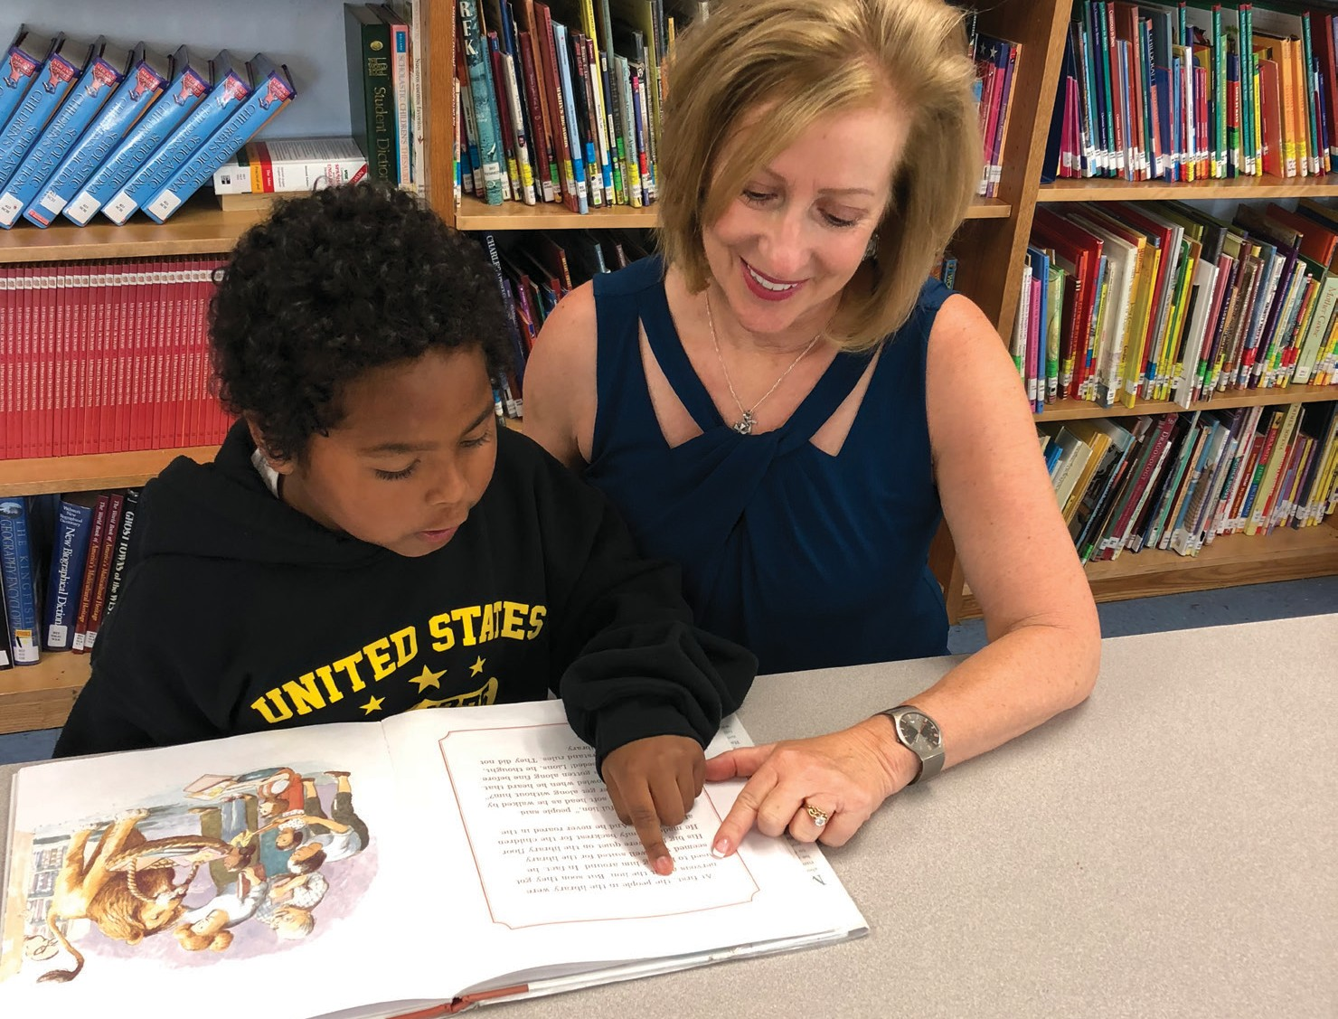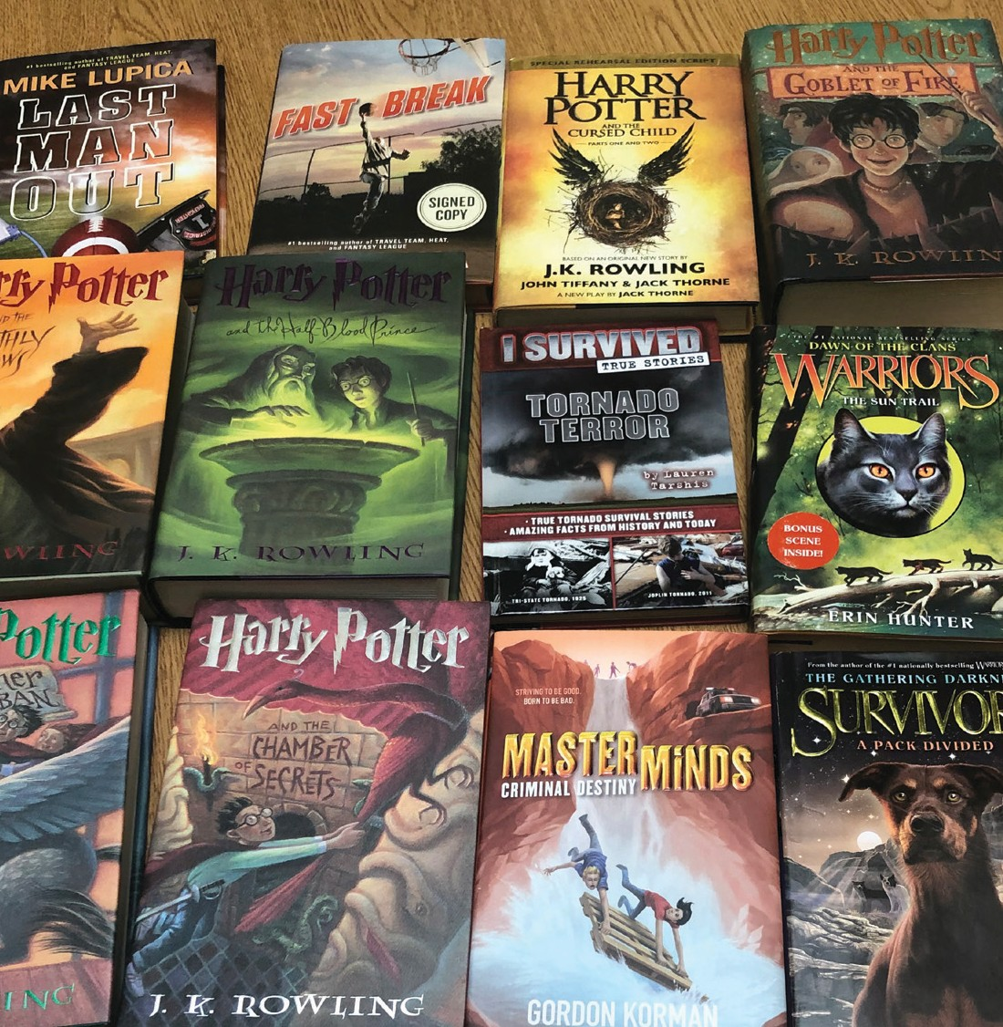If you are interested in volunteering, call us at 760-567-1830 or send an email to readwithmesd@gmail.com.

To contribute make a check out to Read With Me Volunteer Programs, mail to: PO Box 1016, Rancho Mirage, CA 92270 or
Visit our website www.readwithmevolunteers.com to use a credit card through PayPal.
Do please consider including us in your will through your estate plan.

23,365
BOOKS GIVEN AWAY

THIS PAST YEAR we had over 700 volunteers at 14 different schools in the Coachella Valley and two in Nevada tutoring 4,200 disadvantaged children. Volunteers worked in the classroom under the direction of the teacher. In our program, the children who had a volunteer tutor achieved twice as much reading proficiency as the other children in their school. In March 2020, schools were closed.
2020–2021 READ WITH ME VOLUNTEER PROGRAMS BUDGET
 | Projected Budget 2020–2021 | FYE JUNE 30th  Actual 2019–2020 | FYE JUNE 30th  Actual 2018–2019
INCOME
Grants | $205,000.00 | $240,359.00 | $80,500.00
Donations | 170,000.00 | 105,171.85 | 242,820.91
Sub Total Donations | 375,000.00 | 345,530.85 | 323,320.91
Earned Interest Income |  | 52.36 | 52.53
Refunds |  | 48.09 | 2,054.46
Misc. Income
TOTAL REVENUE | $375,000.00 | $345,631.30 | $325,427.90
Investment Income – YTD 2020 | 4,500.00 | 11,856.08 | 3,336.42
(Schwab Unrealized Gains or Loss & Interest and Dividends)
EXPENSES
Accounting Fees | 3,500.00 | 1,345.00 | 1,635.00
Bank Charges | 300.00 | 47.97 | 179.55
Books | 48,000.00 | 48,336.28 | 43,036.03
Buses Transportation | 31,000.00 | 46,500.00 | 48,200.00
Computer Services | 500.00 | 0.00 | 0.00
Employee Wages | 60,000.00 | 55,124.00 | 49,440.00
Field Trips | 10,000.00 | 213.98 | 7,640.72
Fund Raising Expense | 15,000.00 | 14,063.82 | 13,721.53
Insurance | 5,000.00 | 3,949.00 | 3,011.00
Licenses, Permits & Dues | 650.00 | 896.17 | 590.41
Materials | 25,000.00 | 23,009.86 | 15,889.67
Meetings & Travel/Meals | 5,000.00 | 5,058.70 | 5,564.55
Office Expenses | 8,000.00 | 7,854.70 | 4,840.32
Payroll Expenses | 4,800.00 | 4,461.99 | 4,027.16
Postage | 1,300.00 | 969.08 | 1,180.67
PR & Marketing | 27,000.00 | 6,616.69 | 6,910.00
Printing & Stationery | 1,200.00 | 1,051.35 | 1,850.20
Rent | 21,400.00 | 1,200.00 | 1,200.00
Software Licenses | 5,000.00 | 6,038.24 | 3,035.83
Subcontractors Admin. & Program | 72,000.00 | 45,525.94 | 32,340.03
Telephone & Internet | 5,000.00 | 3,968.29 | 4,038.84
Volunteer Appreciation | 21,000.00 | 20,214.13 | 18,908.98
Volunteer Training | 3,000.00 | 311.39 | 0.00
Web Management | 700.00 | 0.00 | 0.00
TOTALS | $374,350.00 | $296,756.58 | $267,240.49
Grants to Schools | 0.00 | 23,755.65 | 33,400.00
TOTAL EXPENSES | $374,350.00 | $320,512.23 | $300,640.49

Now, because of the COVID pandemic, the volunteers will not be allowed on campus, even if the children are there. Working with the CVUSD school district, we have created a program to teach volunteers to tutor remotely on their own computer or electronic device with their students, while under the direction of the teacher, in compliance with District student privacy and protection guidelines.
Computer training will be conducted at several locations four days each week. Five specialists will be conducting the training. Everyone will wear face coverings and comply with social distancing. We will invite our volunteers to register and agree to a background check. Our specialist will load the needed software on the volunteer’s personal electronic devices.
They can attend as many training sessions as necessary until they feel proficient in using their electronic device to communicate with the students, from their own home.
The vast majority of our volunteers are educated, retired individuals. They are fluent in English but have qualms about learning new computer skills. We will make it easy for them to learn these new skills.
We will also have a REMOTE training specialist who will coach by telephone and provide videos for those volunteers work who will not be here locally this year. We will continue giving books to 10,000 children to take home and share with family and friends.
Our mission continues to assure every child in our program has the opportunity to develop to their maximum potential, become productive citizens, fully enjoying the American way of life.
As Winston Churchill has been quoted as saying, “Never, Never, Never give up.” If we don’t give up, the children won’t. Your support is needed more than ever during this trying time.

Sincerely,

RFOUNoDbERe&rtPRaESIKDENTlein
READ WITH ME VOLUNTEER PROGRAMS

READ WITH ME

READ WITH ME BOARD MEMBERS 2020–2021

Roberta Klein
DIRECTOR & PRESIDENT

Steve Schleisman
TREASURER

Clay Klein
SECRETARY

Monsignor Howard Lincoln
SACRED HEART CHURCH

Dan Giovannitti Maria Gandera, PhD
SUPERINTENDENT OF SCHOOLS, CVUSD

Pat Harris Jeannie Morris Horst Engel James Clark

NOTABLE AND QUOTABLE

“Getting books into the homes of our students is extremely important and beneficial to their future. Many of our families do not have the means to purchase books, so when we can provide them with these valuable resources it helps create a more equitable opportunity. Books in homes help students not only with reading, but also vocabulary, comprehension, but essentially learning about the world around us.”
—JESSICA WHITMAN, PRINCIPAL, CATHEDRAL CITY ELEMENTARY SCHOOL

“I have over 100 thank you notes and letters from our students (Grades K-5) expressing how grateful they were for the free books that Read With Me gave them. It was wonderful to watch the smiles and excitement on their faces as the children sorted through the books, trying to find the two special books to take home. One frequent question from the kids was: ‘Do you mean I get to keep this book and own it? Wow, this is so cool. Thank you so much!’ My heart just burst to see the students so excited about receiving their books!”
—LYNN BAERSCH, VOLUNTEER

“After 15 years of Read With Me experience, I continue to be amazed at the students’ eagerness to learn and early age maturity. I sense a mutual enjoyment that is most fulfilling.”
—CLAY KLEIN, VOLUNTEER AND BOARD MEMBER

“Thank you for giving us free books. Now we can practice our reading over the break. Reading every day makes you smarter and you can learn new words. Thank you so much.”
—AITANA, 4TH GRADE, CATHEDRAL CITY ELEMENTARY SCHOOL

STAFF REGISTRATION & COMPUTER TRAINING SPECIALISTS

“If they learn to love reading,

EMPLOYEE

Sherri DeBoer
ADMINISTRATOR

Rachel Luiz

Amanda de Lara

Noemi Guitron
REMOTE PHONE TRAINING SPECIALIST

Louise Cummings
DEVELOPMENT MANAGER

not only does it help them in school by reading at grade level by third grade, and then in high school and maybe college, they can enjoy reading for their entire life and gain so much.”
—SANDY GIOVANNITTI, VOLUNTEER AND

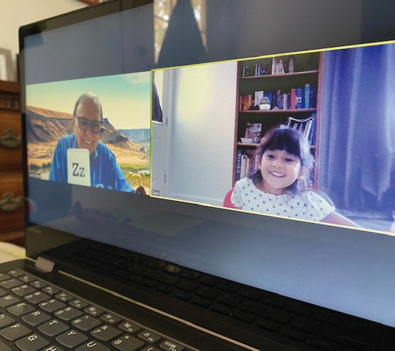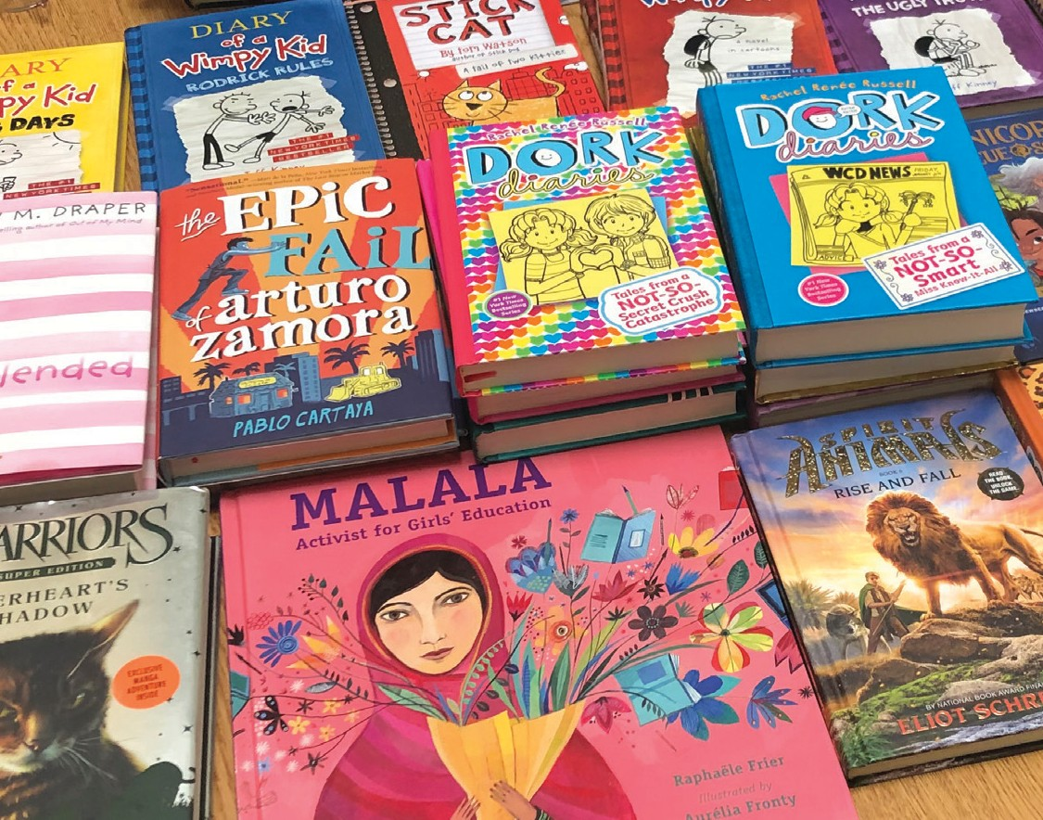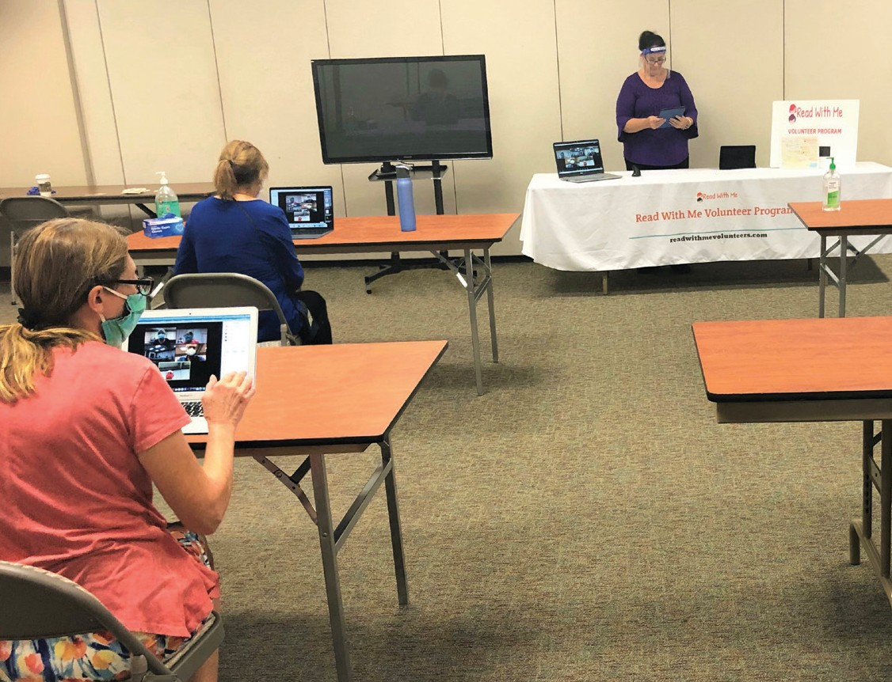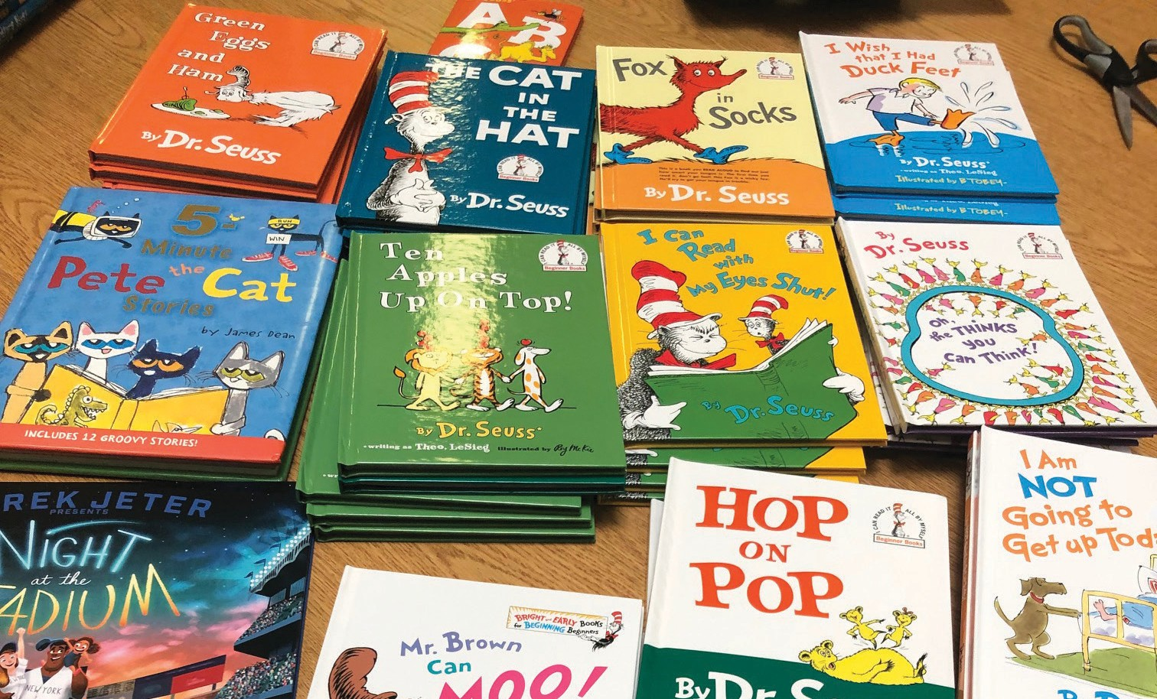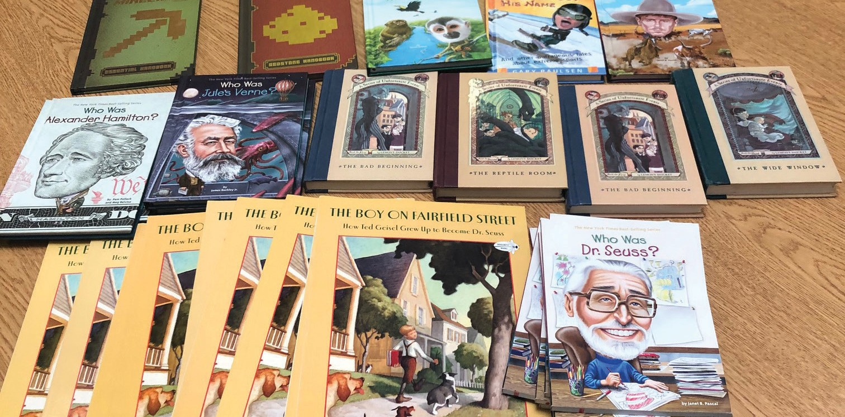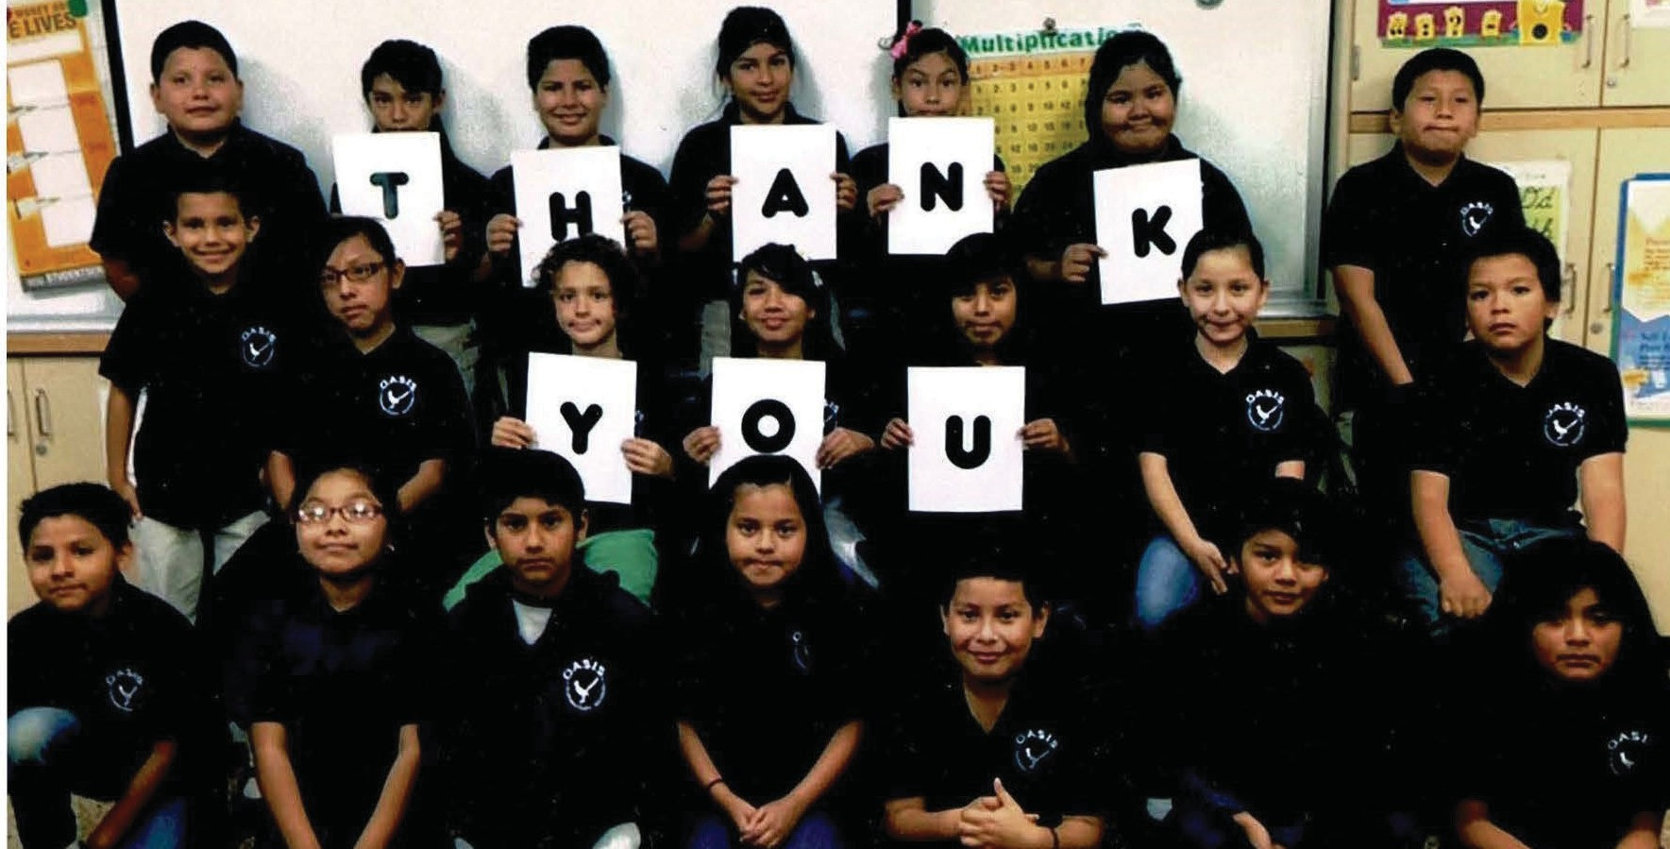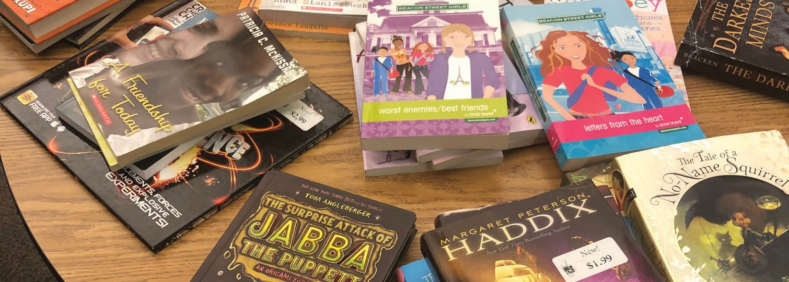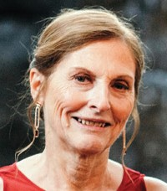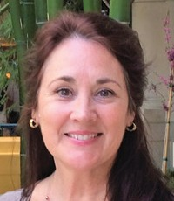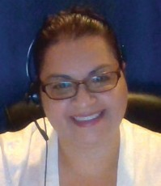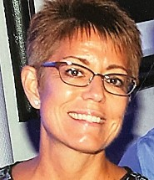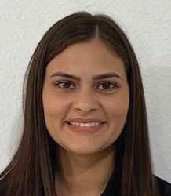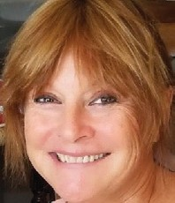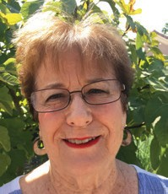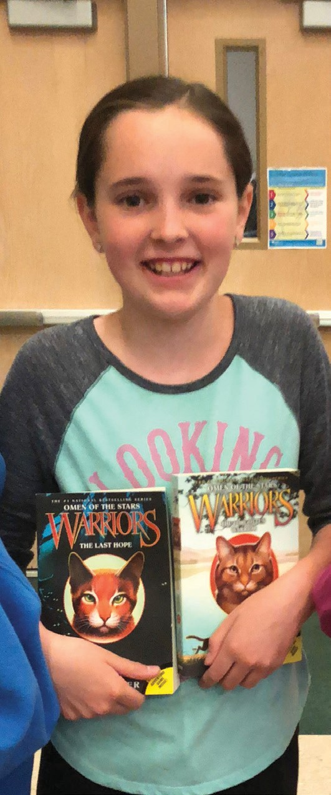
9,015
NUMBER OF STUDENTS SERVED
$48,336.28
BOOKS PURCHASE AMOUNT
VOLUNTEERS LEARNING REMOTE TUTORING
714
ACTIVE VOLUNTEERS

14,961
BOOKS PURCHASED

8,404
BOOKS DONATED
INDEPENDENT CONTRACTORS

Alena Callimanis
PROGRAM COORDINATOR

Judy Hovjacky
RETIRED TEACHER

